

EöTVöS LORÁND UNIVERSITY FACULTY OF INFORMATICS DEPARTMENT OF PROGRAMMING LANGUAGES AND COMPILERS

User friendly chat App

Turcsány-Szabó Márta Edimarf Jaka Jamba Satumbo

Supervisor Computer Science BSc

Budapest, 2020

Contents

1. INTRODUCTION 3

1.1. Motivation 3

1.2. Thesis Structure 4

2. USER DOCUMENTATION 5

2.1. Project Description 5

2.2. Usage Information 6

2.2.1. Getting Started 6

2.2.1. Creating group 7

2.2.1. Starting a conversation 8

2.2.1. Making a video call 8

2.2.1. Creating post and events 8

2.2.1. Settings 9

2.2.1. Reset password 10

3. DEVELOPER DOCUMENTATION 11

3.1. Project Specification 11

3.2. Used Technologies and Methods 11

3.2.1. Backend 11

3.2.1. Frontend 12

3.2.1. Project Resources 12

3.2.1. Databases 12

3.2.1. Authentication 14

3.2.1. Updating data 16

3.2.1. Password Reset 17

3.2.1. Create group 17

3.2.1. Fetching groups from Database 21

3.2.1. Make post and events 22

3.2.1. Video call 23

3.2.1. How view views are managed during video calls 23

4. CONCLUSION 31

5. Reference 32

Chapter 1

# **INTRODUCTION**

## Motivation

Over the past 30 years, internet access is rapidly spread across people, Popularization of smartphones which becomes part of people’s life, and making the interaction of people easiest than before, Communication, sharing of files and many others human relationships [1]. We all have benefited from the existence of internet, but are we safe using it? besides the hacker’s attacks there is no mystery why modern social media platforms were designed to be addictive: the more we consult them, the more data they have to fuel them which enables them to grow smatter and bigger and more powerful. In the year of 2019 many platforms lost thousands of users, especially Facebook which is one of the biggest platforms in the world, after users comprehend how the company was using their personal information. It is important to mention that the term “open-source software” has been going around the internet for a while. It’s actually fairly self-explanatory, even though that might not seem immediately obvious. Basically, there are two types of software: open-source and closed-source, the difference between them is whether the end user has access to the source code. In open-source software, users can view, edit, and delete some of the code. This can be useful for modifying the software to your specific needs, embedding the software inside of an existing program or website, or just taking a few bits and pieces of the software that you need. On the other hand, closed-source software does not allow users to change any information in the source code. The most notable example may be operating software for your computer [2], and many others software, apps, websites which has a big position in the market place. What I would like to point is, any software, social media app, website which refuse to share their code as “open-source” is less trustful, end users should have broad knowledge on how and where they personal data is going to used and for what purpose. This is the main role of this “User friendly App”.

UFCA (User Friendly Chat Application) is a chat app designed for the user safety, providing communication between them requesting few personal information. The app is composed by public groups, post session and event suggestions, strong high security with an open-source, therefore end users can have a broad knowledge of what and how they data are strongly safe and managed, if possible, contribute to it in the possible future.

The application was built above JavaScript framework named React Native [3], which helps writing real natively rendering mobile application for iOS and Android, based on React Facebook’s JavaScript library for building user interfaces, but instead of targeting the browser, targets mobile platforms and gives you more efficient code sharing across the mentioned platforms without scarifying the end user’s experience or application equality [4].

curtail the cost of app development as well. What is more pleasing to note that developers can also reuse the web application codes for creating mobiles app, if they are written in React.

Today, everything is going mobile and cloud, the success of the mobile app is its usage, engagement, and retention because it increases the in-app purchases and boost the app sales. And, storing mobile app data on the cloud makes a huge difference nowadays. [5]

Here, Mobile Backend as a Service (BaaS) proves quite helpful to build functionalities using the cloud that help you offer in your mobile app. Mobile Backend as a Service (MBaas) is a medium that offers a way to link web and mobile application to the backend cloud storage and backend APIs. Commonly known as Backed as a Service (BaaS), MBaaS features like sending push notifications, integrating the cloud storage, user management, and social networks. There are various well-known MBaaS providers such as AWS, Kumulos, Meteor, Kinvey, StackMob, Applicasa, and so on, but the one use for the development of this project was Firebase [5].

Utilization of these tools in our project helps with many of the challenges we face, and makes the development process more efficient and structured. It also provides us with a solid infrastructure to build the application on, and to extend it with new use cases and features.

## Thesis Structure

Chapter 2 of this thesis contains a user documentation, which provides a description of the application and its use cases, a brief overview of the technical methods used in the implementation and how it affects the user experience, and a complete user’s guide for all of the available features of the application.

Chapter 3 is a developer documentation, containing all the technical details of the application. In this chapter we specify all the tasks and challenges of the development process, and provide detailed information about the concepts and components used in the application - including how they function, and how they connect with each other to shape the functionality of the application. API documentation of the main code component of the application can be found in the appendices, which provides detailed information about the classes and functions used in the application.

Chapter 2

# **USER DOCUMENTATION**

## Project Description

The main goal of this project is to create a user-friendly chat app where users can communicate with each other safely, sharing important information, with few personal information required. Focusing on the user data protection the app only supports public groups, users can join any group from the platform using features that makes conversation more interesting such as; image and location sharing. Users can have a broadcast video call among them, the number of members is unlimited, functions can such microphone and camera can be enabling and disabling depending of user preferences.

To provide a better iteration among users there is two important session, beside the Chat groups. The `Post` session allows user to have a small social media inside the app, where they can share images and a small description about it, other users can also have access to the same post, with options to save or share with extra apps of their wish. The `Event` session is a small part of the app, that users can give some highlights of the upcoming events around the world, more information of the same events are only accessible from an extra linking provide on the description.

High user-friendly UI provided for end users, and strong data protection for they safety.

Additionally, chats are provided as public and video calls as broadcast (“live video call”), but they are implemented in the way that allows extending the application of possible implementation of the feature peer-2-peer communication, if in the future it requires.

In this project, we have used React Native which is an excising framework that enables web developers to create robust mobile applications using their existing JavaScript knowledge. It offers faster mobile development, and more efficient code sharing across iOS/Android and the web, without sacrificing the end user’s experience or application quality. Using React Native solution, we are able to deliver a scalable and highly quality applications, saving in development time, cost and the effort could be cut by half.

Cloud technology is used in this project to contain and process all of the application resources, and offers on-demand storage and processing power that we require for the application. Using Firebase removes the need for buying or renting servers to hold the application, and eliminates the burden of having to maintain and configure the servers and lets us focus only on development on a reliable infrastructure [1].

## Usage Information

### Getting Started

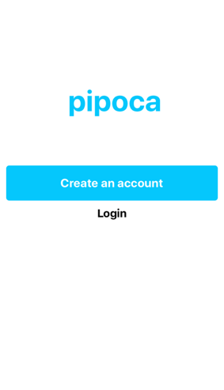

Figure 1 Get Start screen.

When the app is started, `Get Start` screen is present [“Figure 1”], where they will have options to create or login to their exist account. Click on the “Create an account” implies that user is not registered yet and pretends to create one. From the `Sign in` screen contains a form to be filled, requesting `email and password` as a first step. Only with valid email and pass word is possible to complete the session. After a successful API check as last form information such as name, id, location and bio will be need to finalize. The user’s `Bio` will contain as maximum length 40 characters. This information is extra from users, and they are required. With a successful completion from the required data, clicking on “Finish” a new account will be created, allowing users future unlimited access to app.

In case of having already an account clicking on “Login”, user will be asked to provide they valid `email and password`, if success on login the main screen will be present otherwise, they will face an error message similar as the figure below in [“Figure 2”]:

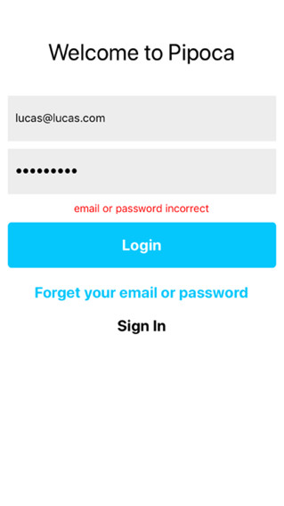

Figure 2 Long in screen

### Creating group

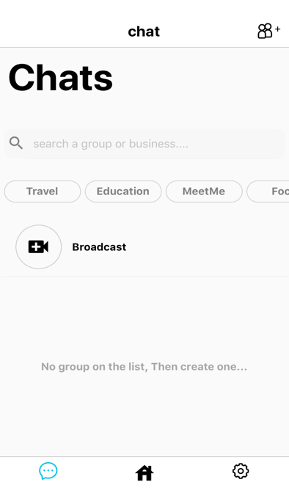

Figure 3 Chat screen

Upon on the top right part of the screen there is an icon bottom [“Figure 3”], which

clicking on it navigates to the `Create group` screen. User will face a new screen which contains a form that requires a name and image for the group, default information is provided by the app such as: name, image and category. This information can be altered, by the user preferences. The categories are important to distinguish the topics of each groups, making easy the search of the topics in the app.

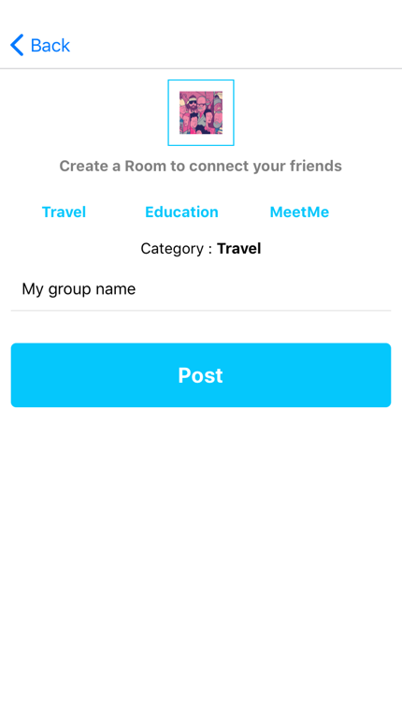

Figure 4 Create Group

As the last step user must click on the “Post” which finalize the process and posteriorly navigate user back to the Chat screen where the new group can be found [“Figure 4”].

### Starting a conversation

From the `Chat screen`, a list of groups can be found, to be able to start a conversation, a simple click on the desired group can navigate the user to the ` Message screen`, where they can send message, images and specially their location. Taking in consideration the user’s privacy, all of these features are possible to use if and only if users permit and agree. It is only possible to navigate through the map from the chat, future connections with Maps application will be implemented if in the future require [“Figure 5”]..

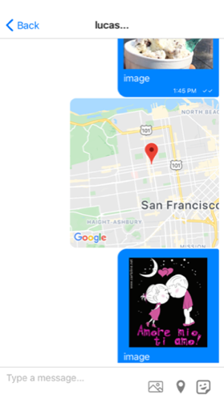

Figure 5 Message screen

### Making a video call

The app offers a broadcast video call, which any number of users are allowed to participate, from the Chat screen a ` Broadcast sections` is found right on the top of group list, clicking on the icon button will navigate the user to the video call session, where they can communicate using features such as microphone and camera. This function can be enabled and disabled by the user preference.

### Creating post and events

To be able to create a post or events user must navigate to `Home screen` which from the tab navigation is designed as the `home icon`. The `Home screen` is divided in two session; post and events. From the post session users: right on top of list of posts a button composed by icons can be found, clicking on the button, we will navigate to a next screen, and provide image and description for the post. Description is considered as optional rather than image which is requirement. Pressing `post` a new post will be created and prosperously navigate users to the previous screen. Some functionalities will be available to user, they will be allowed to save, share link and delete their own post.

“Figure 4” shows that from `Events` session, a button named `Create Event` will be located right on the top of event lists, clicking on the button, a new screen will be present, where they will have a form to fill out with necessary information such as: event name, category, location, website link and date of the event. A website and respective date of the event are required, with a successful completion clicking on the “Post” button will create a new event and navigate user to the event list.

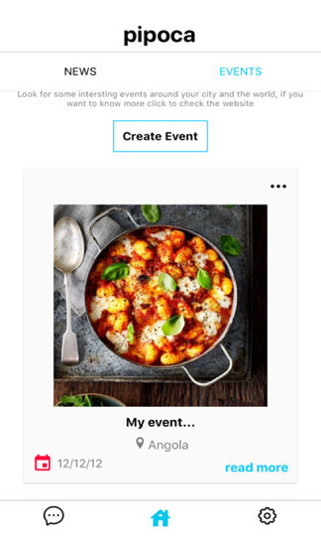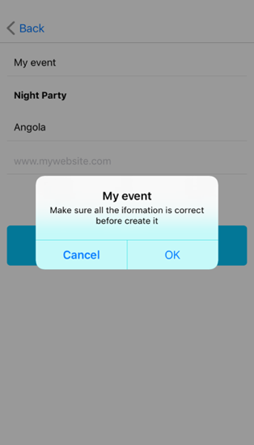

Figure 6 Screenshot of Create event screen

### Settings

Settings is the last session of the app, where users can update and delete some private information, with the possibility to alter they personal data, saved list of post and groups, and logout the app at any wished time. User can navigate to the “Account”, where they will have access to the extra information provided during the account registration such as: user name, id, location and bio as shown in [“Figure 7”].

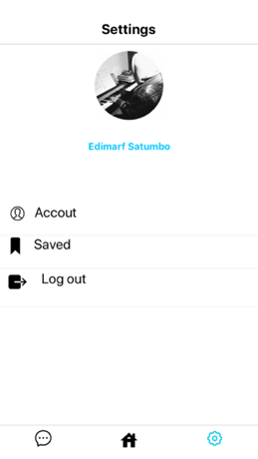

Figure 7 Setting screen

Important to remind that groups and posts can be saved, to be able to get access to them user can navigate to the “Saved” session, they can get the names of the favorite groups even previsualize images that they have saved, an illustration can be found in [“Figure 8”].

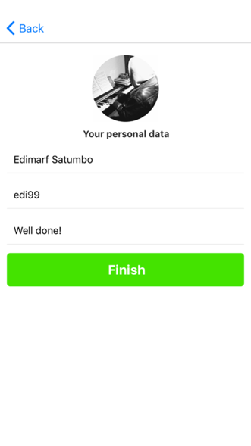 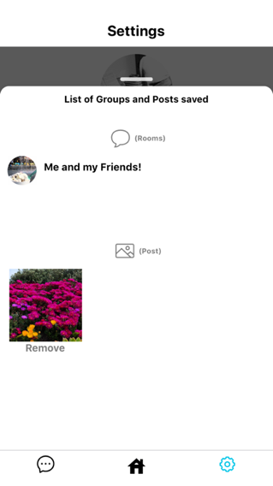

Figure 8 Account

Figure 9 Saved sessions

The last part we have the “Logout” button, clicking on it means that users want to leave the app, and automatically disconnect and navigate them to Get Start session, where they can login again at any time they wish.

### Reset password

In case user forget his password, a session is provided, where user with valid email, can update their password, by requesting a link which enables to them to reset through a website, see [“Figure 10”].

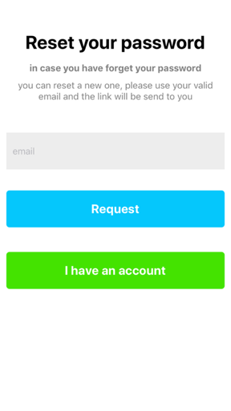

Figure 10 Reset Password screen

Chapter 3

# DEVELOPER DOCUMENTATION

## Project Specification

The goal of this project is to create a modern user-friendly platform to provide communication between users and keep their information safe. This platform is offered as mobile application. The main challenges of the project can be summarized as following:

* Providing a secure way of authenticating users into the system.
* Creating a modern user-friendly interface.
* Providing video call using WebRTC technology
* Maintaining the user data and list of chat from each group to the Database.
* Creating a logical structure that can be easily maintained and extended with new features.
* Allowing user to send their own location through the chat using Android/iOS emulators.
* Converting images to jpg format to be able to handle them in Database.
* Implementing libraries that requires real devices, and overcome a new way of implementation
* Optimizing functionalities for a well performance of the app
* Provide the right rules to store the messages in Firebase Database.
* Share location through google API from different platforms iOS/Android
* Migrating from WebRTC library to Broadcast calls with free APIs.
* Moving from Expo to React Native CLI
* Reduce the work from Socket.io implementing Firebase for communication between user in a single library.
* Constancy of the UI from different platforms.
* Difficulty of finding free APIs for good features.

## Used Technologies and Methods

### Backend

The backend is implemented using Firebase which is Google database, for mobile and web development, supporting Android/iOS platforms. For the video calls we used Vonage Video API which is built on the top of WebRTC for real-time communication capabilities. It supports video, and generic data to be send between peers, allowing developers to build powerful voice-and video-communication solutions. The technology is available on all modern browsers as well as on native clients for all major platforms. The technologies behind WebRTC are implemented as an open web standard and available as regular JavaScript APIs in all major browsers. For native clients, like Android and iOS applications, a library is available that provides the same functionality. The WebRTC project is open-source and support by Apple, Google, Microsoft and Mozilla, amongst others. For our project we are focused on mobile environment [6] [7].

### Frontend

The frontend is implemented using React Native, an open-source mobile framework based on JavaScript that allows you to build natively-rendered mobile apps for iOS and Android. This framework lets us to create an application for various platforms buy using the same codebase. The fact that React Native actually renders using its host platform’s standard rendering APIs enables it to stand out from most existing methods of cross-platform application development, like Cordova or Ionic. Existing methods of writing mobile applications using combinations of JavaScript, HTML and CSS typically render using Webviews. While this approach can work, it also comes with drawbacks, especially around performance.

For developers accustomed to working on the Web with React, this means you can write mobile apps with the performance and look and feel of a native application, while using familiar tools. React Native also represents an improvement over normal mobile development in two other areas: the developer experience and cross-platform development potential.

Working with React Native can dramatically shrink the resources required to build mobile applications. Any developer who knows how to write React code can now target the Web, iOS and Android, all with the same skillset. By removing the need to “silo” developers based on their target platform, React Native lets your team iterate more quickly, and share knowledge and resources more effectively.

### Project Resources

In this section we will provide detailed information on each of the resources of

the application and how they function.

### Databases

Firebase is a toolset from Google used to “build, improve, and grow your app”, and the tools gives you cover a large portion of the services that developers would normally have to build themselves, but don’t really want to build, because they’d rather be focusing on the experience itself. This includes things like analytics, authentication, databases, configuration, file storage, push messaging and the list goes on. The services are hosted in the cloud, and scale with little to no effort on the part of the developer.

Exist different ways of authentication in the Firebase environment, the one used in this project, was “Email/Password”, which allows users to sign up using their valid information, with SDKs providing email address verification, password recovery, and email address change primitives.

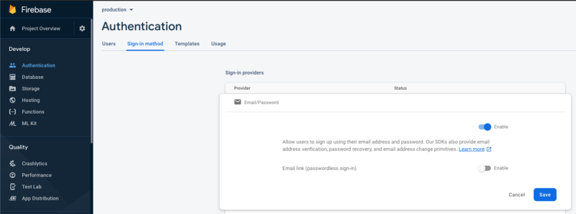

Figure 11 Firebase console

We need to enable the Email and Password verification, in case of the type be our preference, see the [“Figure 11”]..

React Native works with native codes from both Platforms, for each of them we must register. Getting the ID’s both for Android and iOS are required, and it drives us to a successful usage, see the [“Figure 12”] .

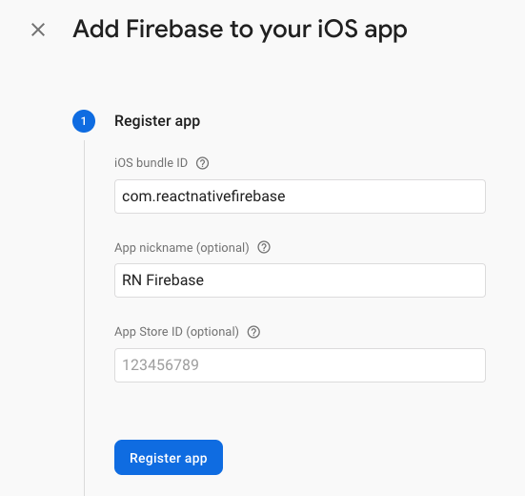

Figure 12 Firebase console

As mentioned before, Firebase is NoSQL Database, the data has a different way of dealing, there exist `Rules` to be set. In this session we are setting the rules for users, meaning that only users which has an account in our app is allowed to read and write his own data from Realtime Database, see the [“Figure 10”].

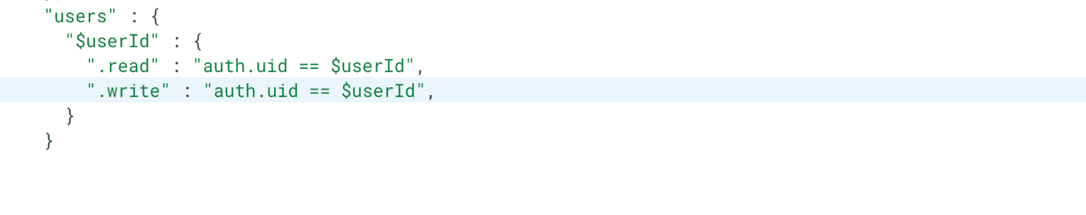

Figure 13 Screenshot of Firebase Realtime database rules

Since we are implementing two distinct Database for this project, we also have an illustration of the same rules on Cloud Firebase. Meaning exactly the same thing from the Realtime Database, see the [“Figure 10”].

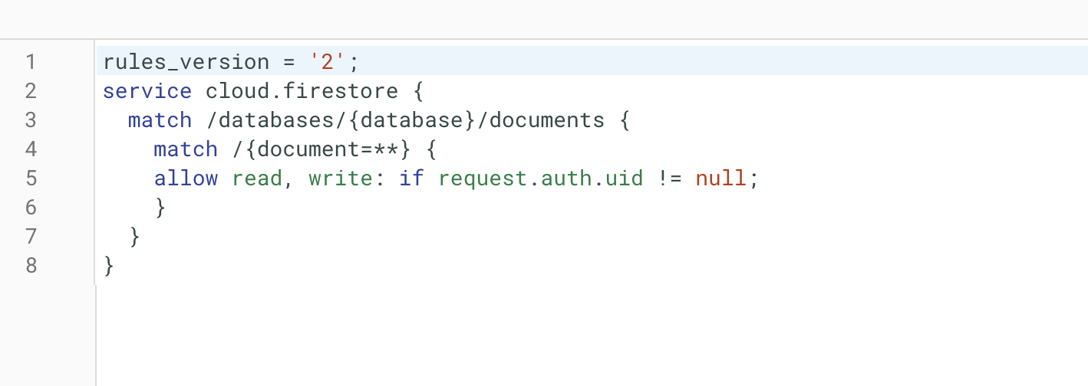

Figure 14 Screenshot of Cloud Firebase rules

### Authentication

For authentication session we used Redux state management, which is a predictable state container designed to help you write JavaScript apps that behave consistently across client, server, and native environments and are easy to test. While it’s mostly used as a state management tool with React, React and native any other JavaScript framework or library.

The `loginUSER({ email, password}) ` function requires two important information of user, their email and password. The `signInWithEmailAndPasword` is sending the data to the Firebase Database API checking if provided data is valid. In case of successful checking a new function is called `loginUSER_SUCCESS` which posteriorly drive us suer to the main screen with the help of `Action` function, in case of unsuccessful login the loginUSER_FAIL is called and updates the `error` state which will be displayed an error message on the screen of user screen, see the [“Figure 15”]..

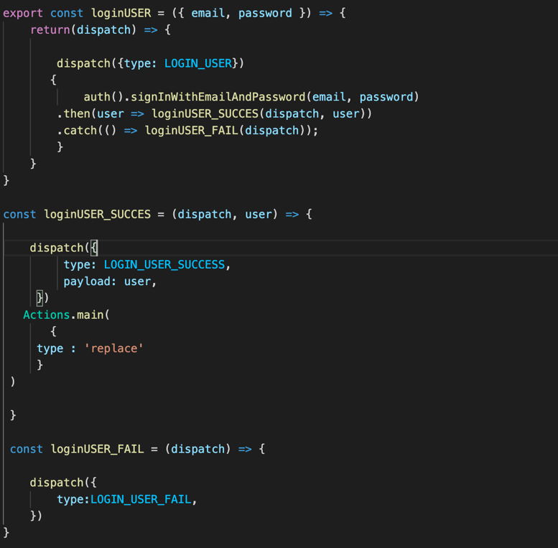

Figure 15 Screenshot of LoginUSER function

For creating account, we followed the same logic as the login session, firstly we check if the provided data is valid, and posteriorly we moved to the next screen. Here can be found below the Figure. 16:

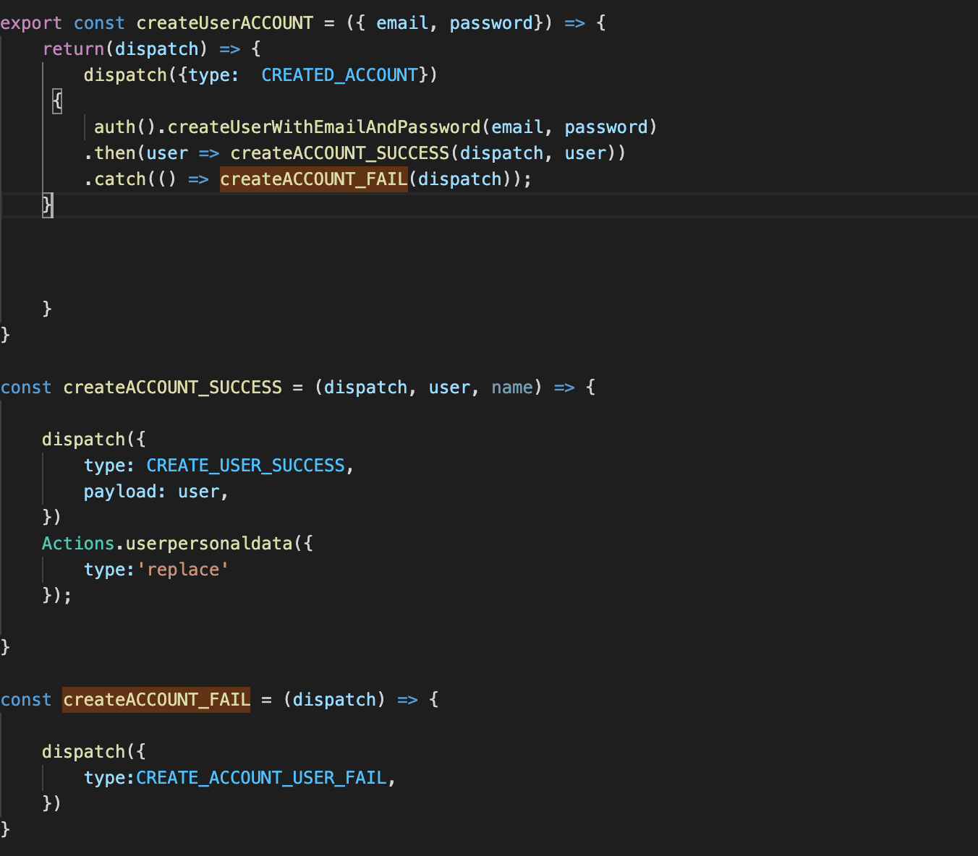

Figure 16 createUserACCOUNT

From `createUserACCOUNT` user will take a different path, after providing their email and password they will be drive to the “UserPersonalDataScreen.js”, where they can provide more information such as: userName, userID, userLocation, userBio, check the [“Figure 17”].

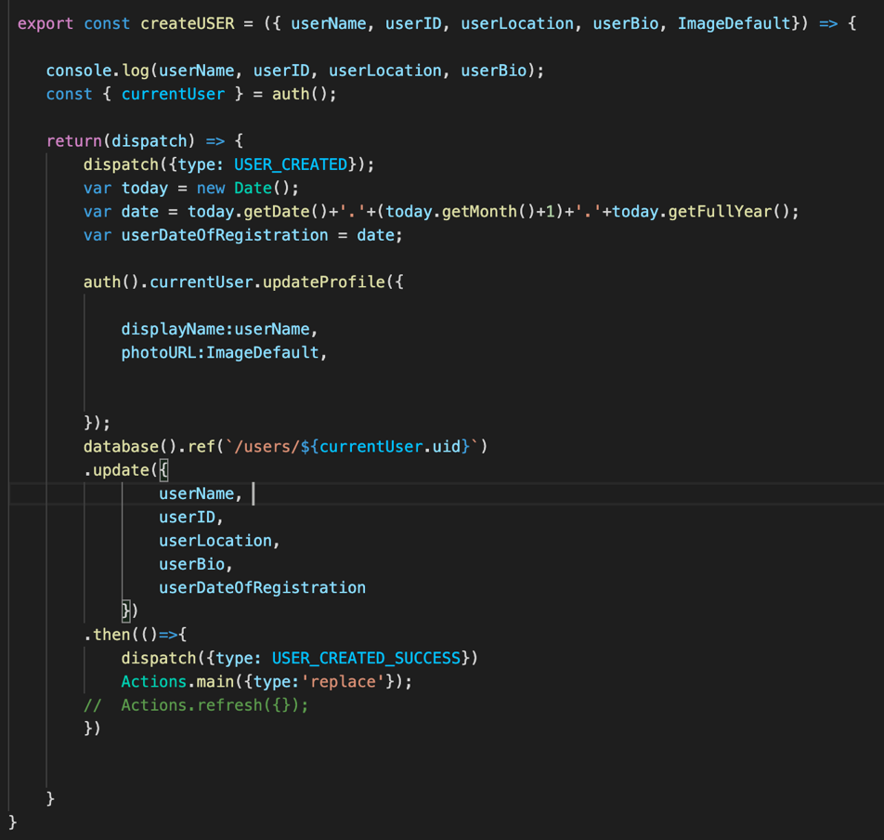

Figure 17 createUSER function

We set the property `ImageDefault` to prevent an error from the `Image` React Native View which does not support null or undefined URLs.

### Updating data

Providing an update function, which allows user to update their personal information, `updateUSER` is taking four parameters (` userName, userID, userLocation and userBio`), each of this data can be updated separately, and posteriorly they will be sent to the database using the function `database().ref(…).then()`, which takes an reference to where data must be updated and pop the current screen driving users to the previous one after successfully updating, see [“Figure 18”].

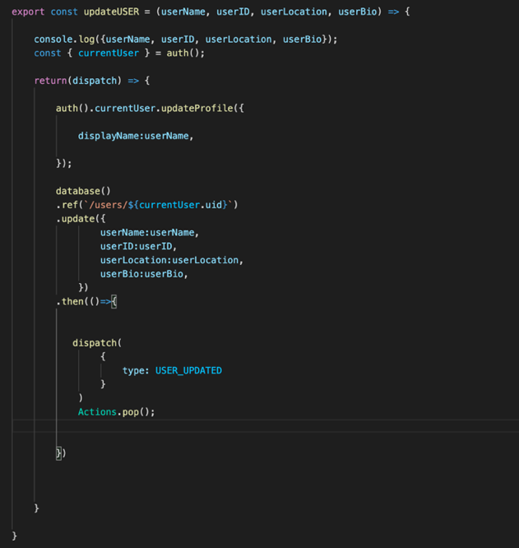

Figure 18 updateUSER function

### Password Reset

In case user forget their email or password, there is a possible to recover it, here we used the function `forgotPASSWORD` which takes only email as a parameter and calls the `**s**endPasswordResetEmail` function for posteriorly send the link of the reset password web page provided from Firebase system. Also, some errors are catch in case the email is not valid.

Figure. 19 for the last step we used `emptyALL_FIELDS`, we would like to ensure that after a successful step, the fields remain empty for a future action. See the below [“Figure 19”].

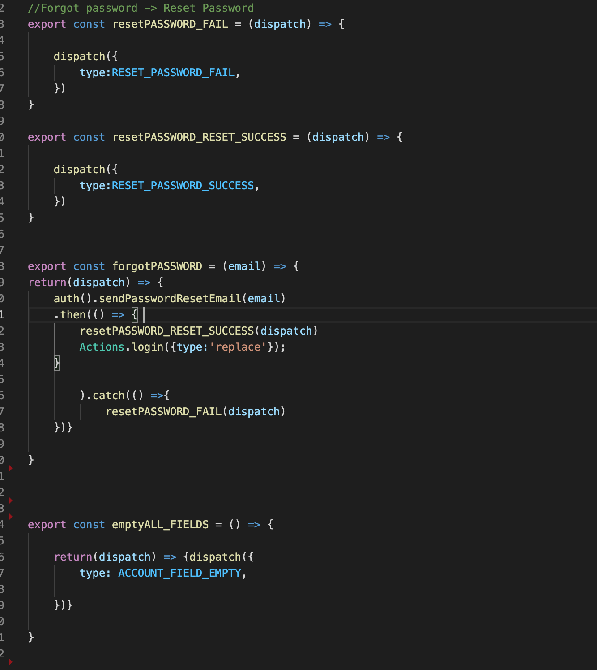

Figure 19 resetPASSWORD function

### Create group

The create group session is taking important states, which will help us knowing the actual state of our progress as shown in the figure below [“Figure 20”]:

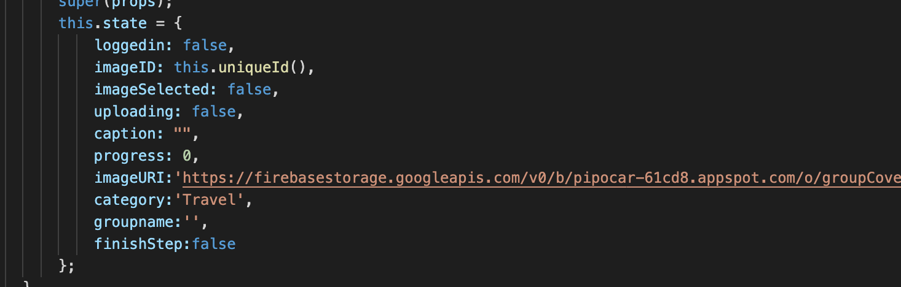

Figure 20 Screenshot of the code on Create group

Groups are composed by: name, images and categories. We defined a default image for groups which is fetched from our database, with categories state receives `Travel` as default value. To be able to access images on devices we use the helper function called `_checkPermition` which ask user permission to access the images from their devices, this function can return different states such as `DENIED` which means user denied the permission but a future request can be made, `GRANTEND` meaning user is agree and allowed the device to have access to the gallery, `BLOCK` which blocks the device to access the gallery and no future request can be made and `UNAVAILABLE` which is present when the version of the device does not support that the actual feature, see the [“Figure 21”].

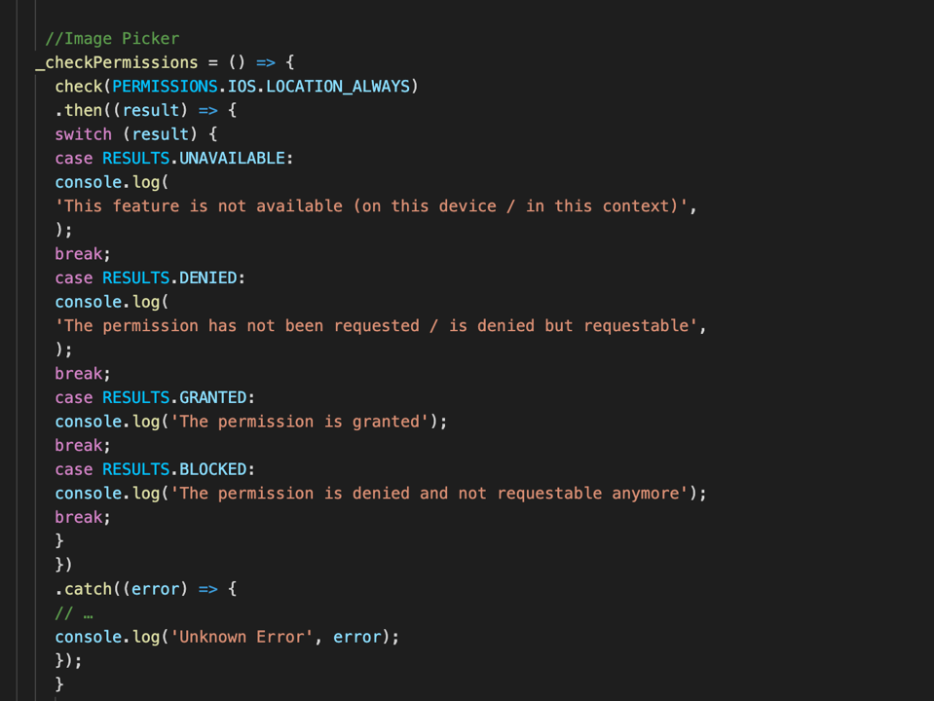

Figure 21 Create group

User agreeing and permit the device access the gallery, a helper function will be need `findNewImage` , which will help users to select the desired Image, also, with the option to cancel the action.

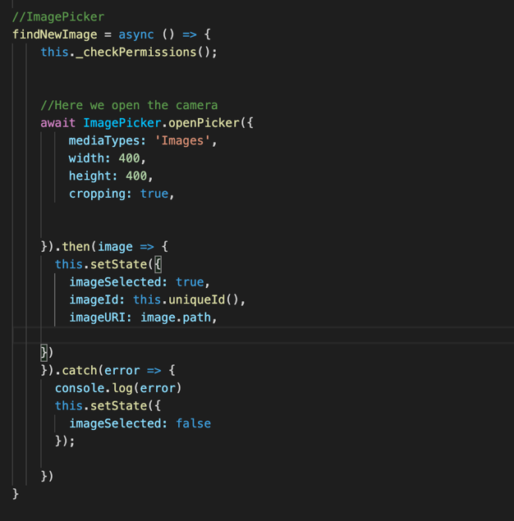

Figure 22 Screenshot of the code on Create group

After selecting the desired images, a unique id is necessary for each of them. `S4` and `uniqueId` will help us to generate random ids to prevent and avoid images containing the same Ids which would cause a conflict on the database point of view.

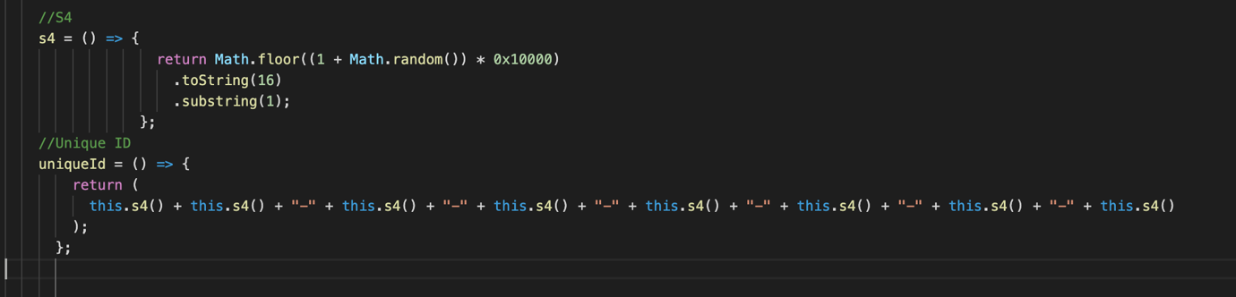

Figure 23 Screenshot of the code from Create group

After this point, we upload the image on our Firebase Storage, given a reference folder as `POST/img`. With a successful upload we download the URL from our database `downloadURL`, with this link we pass to the `processUpload` function.

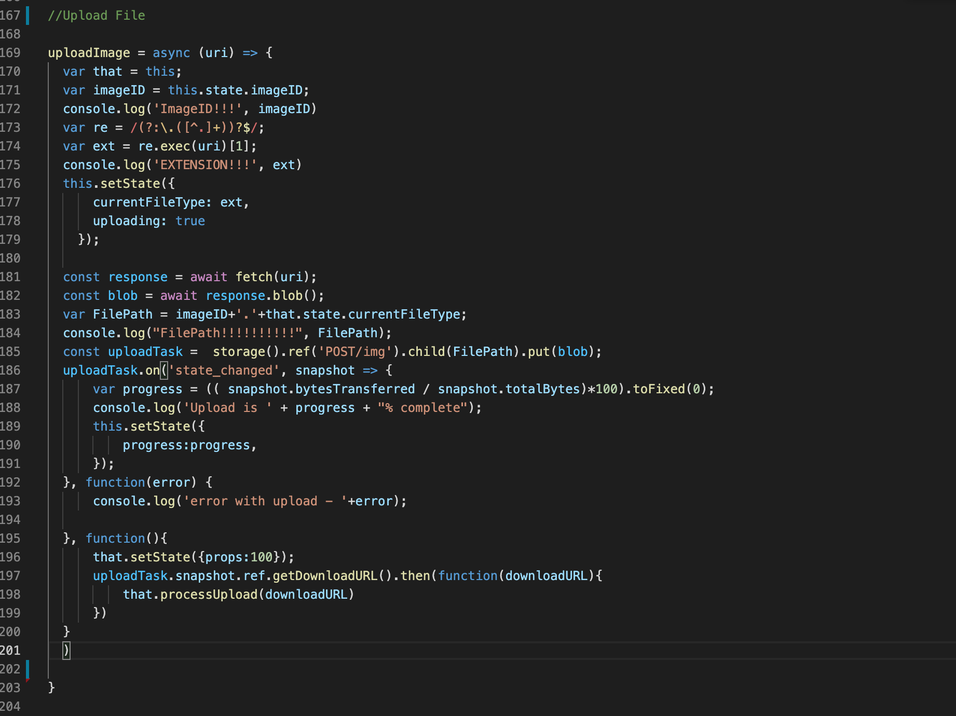

Figure 24 Screenshot of the code from Create group

From `processUpload` function we pass the final properties that will be fetched to the database, such as: name, groupcover, category, author and lastestMessages. Remind that all this information is required to create a group, unless they are provided by default.

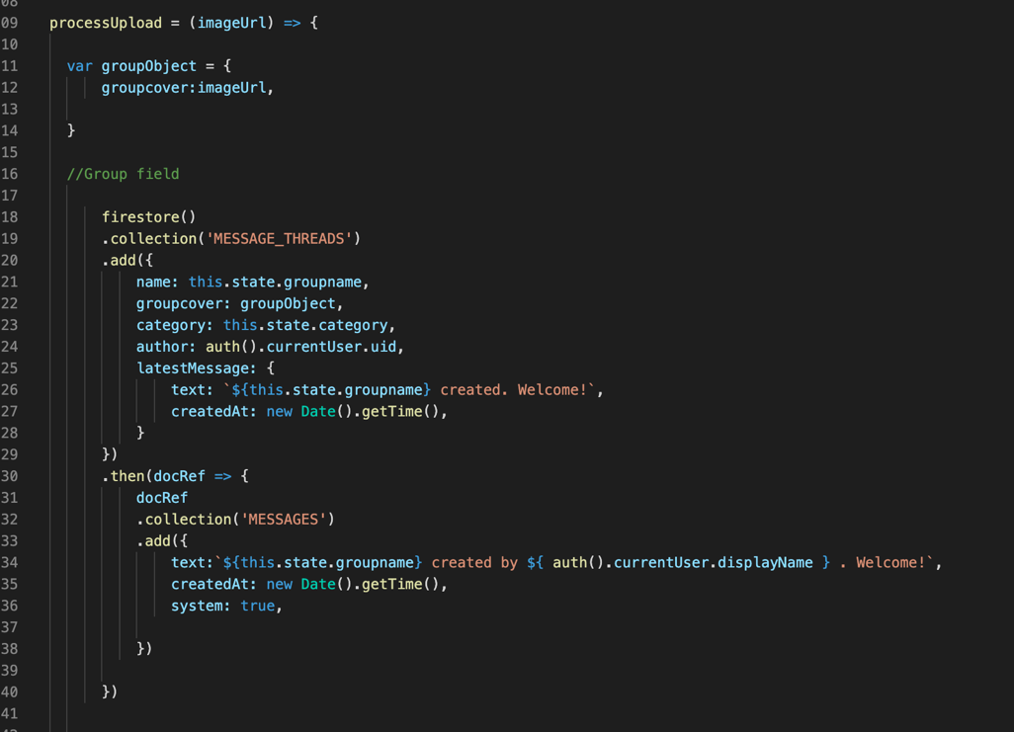

Figure 25 Screenshot of the code from Create group

The function `UploadPublish` is helper method which has inside the `uploadImage` function, so, this will be called later on `onButtonPress` method to be able to complete the process.

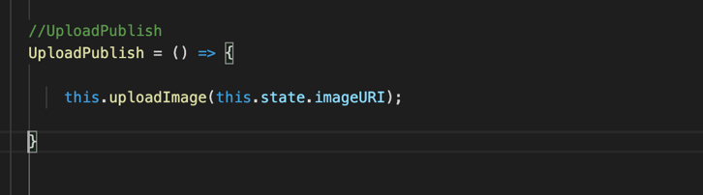

Figure 26 Screenshot of the code from Create group

From `onButtonPress` we used an Alert function; this is to let user know if the provided data is the one that they want to upload, since the app does not offer a possible edition after the group be created. Alert takes two important options “Cancel” and “OK”. As the name implies, canceling aborts the action and in the other hand we create the group.

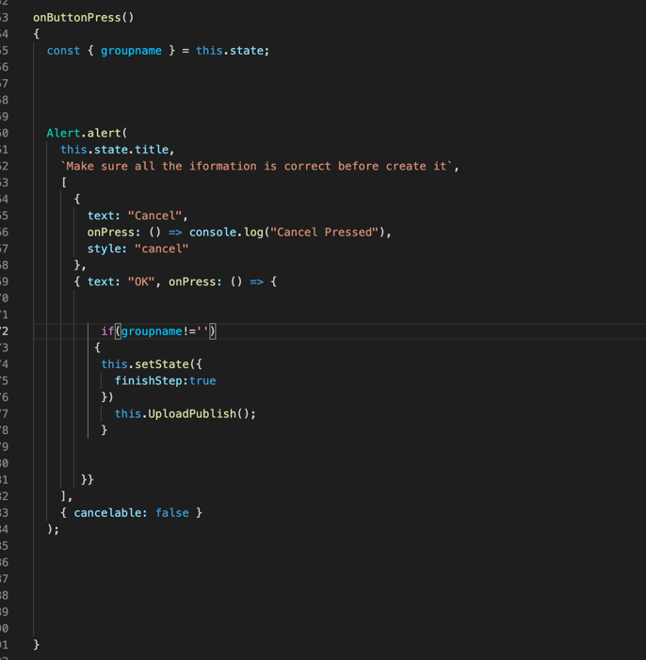

Figure 27 Screenshot of the code from Create group

### Fetching groups from Database

For obtain the groups that we have created, we use the function `fetchGROUP`, which divis into our database in the collection named `MESSAGE_THREADS`, with possibility of getting the `latestMessage` sent to the group.

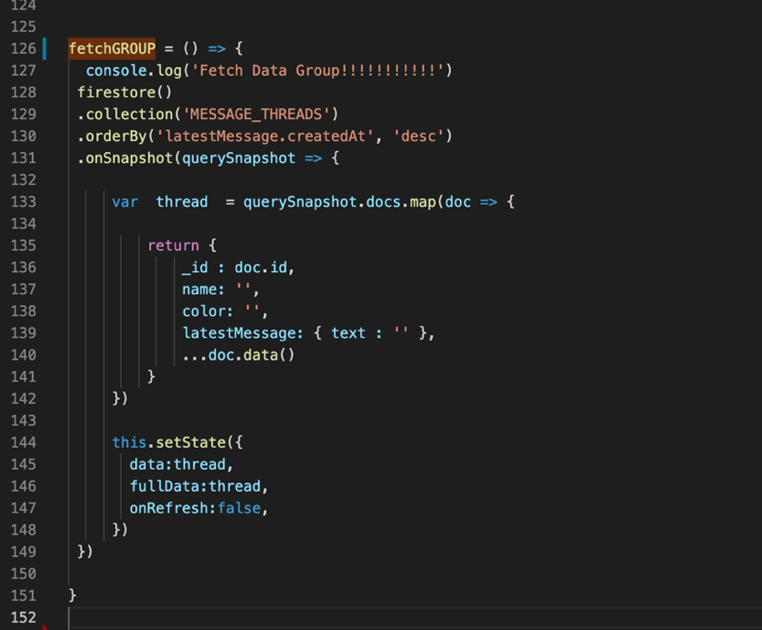

Figure 28 Create group

### Make post and events

The process of creating Posts and Events is really similar as the creating group section, here we will show the distinct functions that each of them possess. They all have the similar structure only the `processUpload` functions properties changes. below is shown the function of `Post` session.

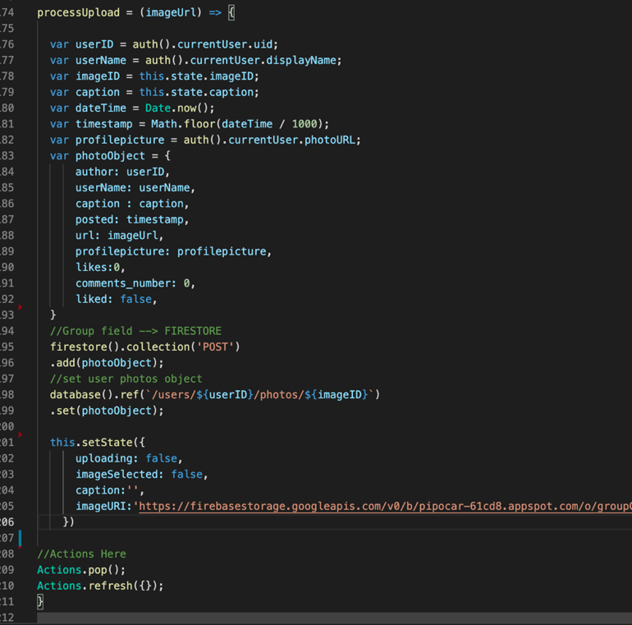

Figure 29 Create group

Here we asked important information such as caption which is the description, the author’s name and the URL of the post.

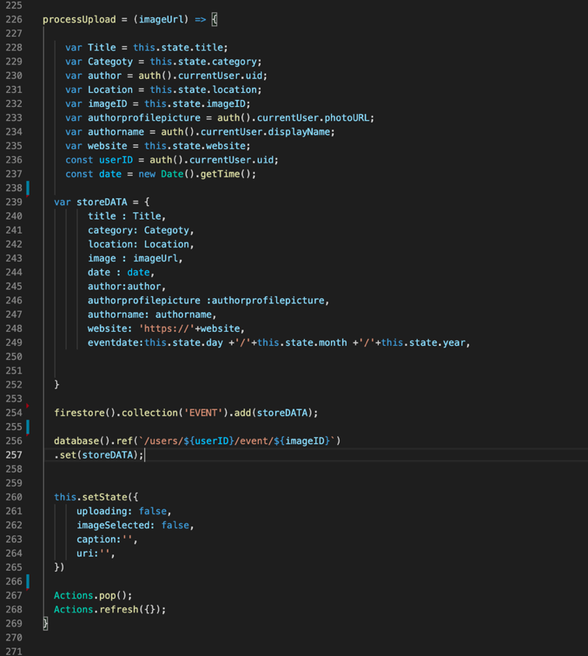

Figure 30 Create group

For Event session we take important information such as event title, category, image URL, event date and if possibly a website link.

### Video call

Nowadays video call apps have become a well-integrated habit in our lives. Here we show how incredibly fast and straightforward it can be to integrate video call functionality using React Native and Vonage Video API SDK, which is a WebRTC based solution. It supports many platforms, among these are browsers, Android, iOS, Windows and macOS. We use the API to create broadcast video sessions between our different roles [7].

The `JoinCall` property on React state will trigger different views based on the value. When the App is lunched, a simple View with a “Join the Call” button will be displayed to the user. The button will trigger a state change and toggle the `joinCall` value to show the more complex videocall view [7].

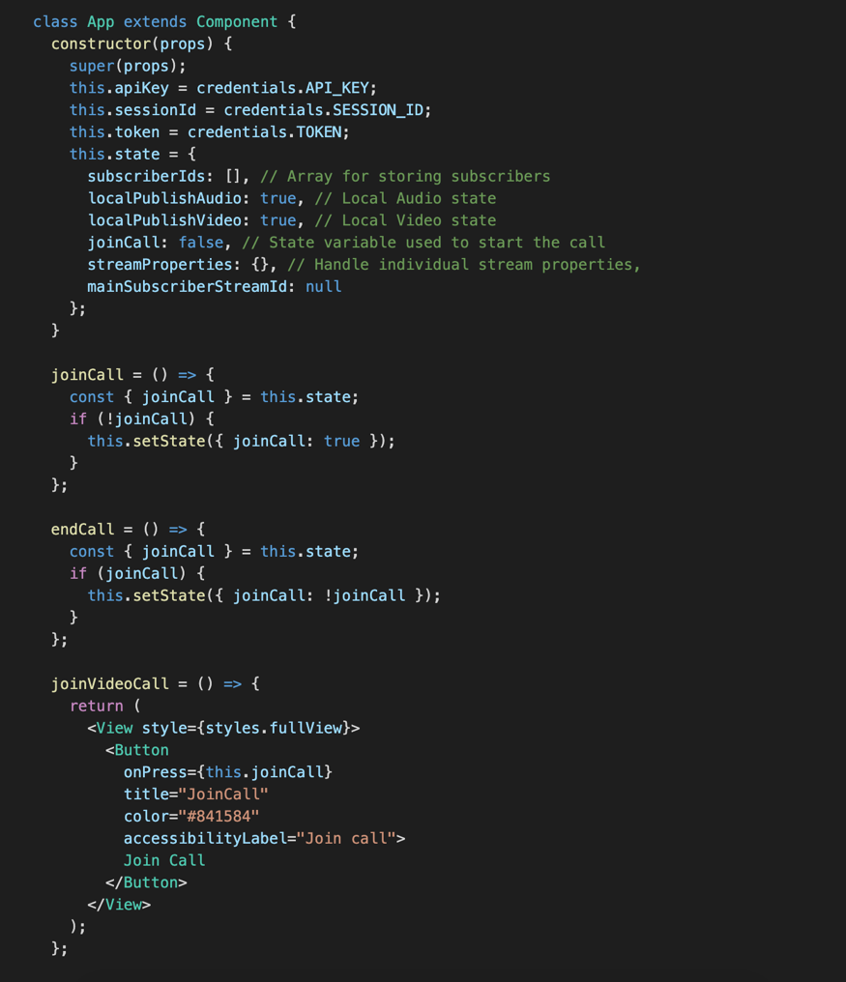

Figure 31 Screenshot of the code from Create group

### How view views are managed during video calls

Before digging into videocall View, it’s worth spending time exploring the `opentok-react-native` library.

The library is composed of the three main components: `OTSession`, `OTPublisher` and `OTSubscriber `. Each of them will interact with the native layer (iOS and Android), calling the native methods to connect, publish and subscribe. We will also need to listen to the events fired by those components, especially the session events, such as `sessionConnected`, `sessionDisconnected`, `streamCreated` and `streamDestroyed` [7] [8].

The videocall View is composed of the following components: Publisher, Subscribers and a ToolBar on the bottom side to control the microphone and camera and to end the call as shown in Figure 31 [7].

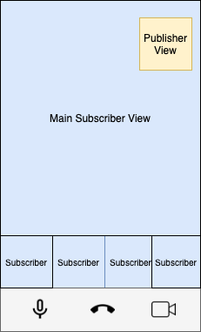

Figure 32 Vonage view blueprint

To build the above View, we need to keep track of the subscriber’s streams, the primary subscriber, and the local microphone and camera publishing state. The perfect place to store this information is the React State [7].

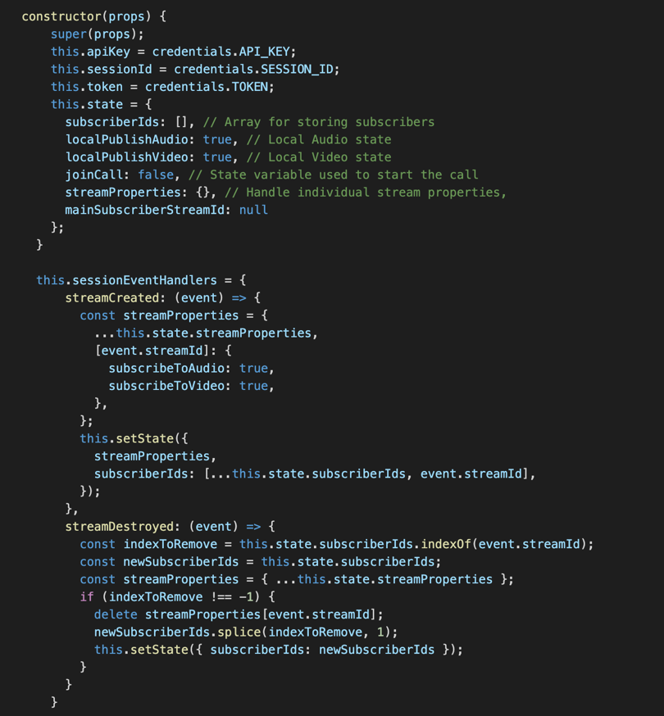

Figure 33 Video call

`SubscriberIds` array stores the subscribers within a session. Each time we receive a streamCreated event, it means that someone has joined the session and published a stream, so we need to add their streamId on the `subscriberIds` array. On the other hand, when we received the `streamDestroyed` event, we need to remove the streamId from the subscribers’ array [7].

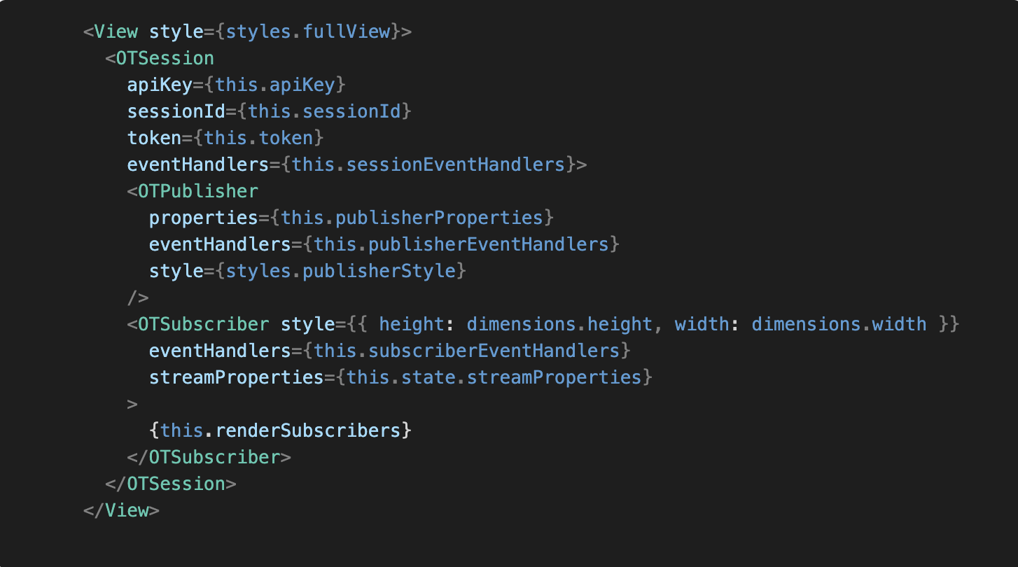

Figure 34

On the video view render function, we need to add `OTSession`, `OTPublisher` AND `OTSubscriber` from `opentok-react-native` libray. On the `OTSession` we set the credentials and the eventHandler function as props of th

e component [7].

The `OTPublisher` component will initialize a publisher and publish to the specified session upon mounting. It’s possible to specify different properties, such as camera position, resolution, and etc. In this session we will only set `this.publisherProperties = { cameraPosition: ‘front’};` [7].

Ensure you have enabled both camera and microphone usage by adding the following enters entries to your `Info.plist` file (iOS project):

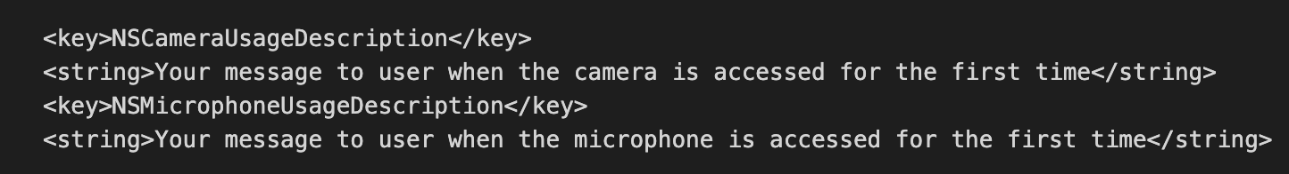

Figure 35

Alternatively, for Android 6.0 add the following (newer version of `API Level 23`) :

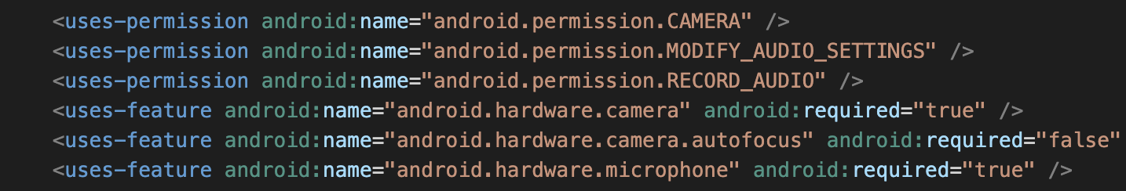

Figure 36

The `OTPublisher` component has a `streamProperty` property which handles the publisher properties passed into the native instance. Using the React State, we can trigger changes to the Publisher instance by updating the `this.publisherProperties` variavle. We use this approach to implement the Toolbar with the mute/unmute functions for the Microphone and Camera. The function implementation is straightforward; it toggles the publishAudio or publishVideo value on the `this.publisherProperties` and the `localPublishAudio` and `localPublishVideo` to adjust the button icon based on the value.

The End Call button has a very similar approach. The `endCall` function toggles the `joinCall` value in the State and resets the View to the initial one [7].

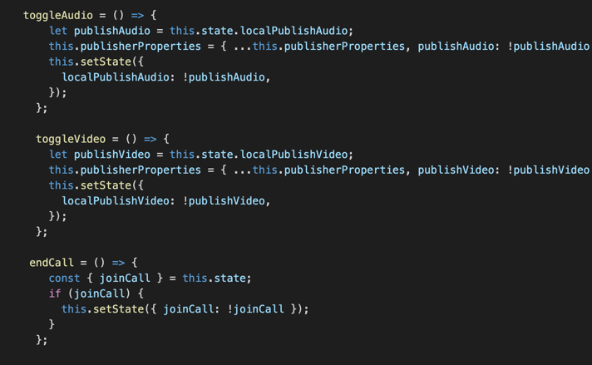

Figure 37

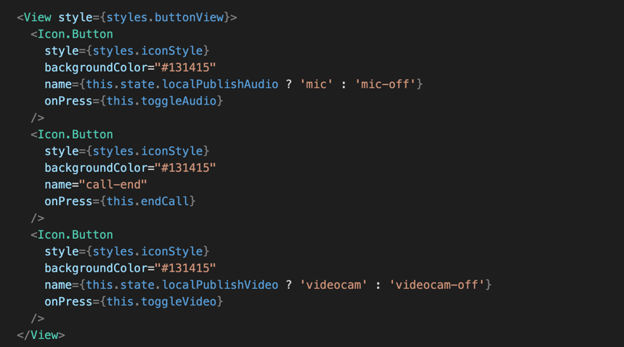

Figure 38

At this point we have implemented the Join Call View, the session and Publisher component, and the Toolbar. Next, we will define the View for the different possible number of subscribers. If we have no users, we are going to display a Loading spinner [7].

If we have only one subscriber, we will display their stream in full-screen mode.

Finally, if we have more than one user, we will show the primary subscriber in the big View (as shown in the mock-up), and the other in a Scroll View component to handle a different number of subscribers. As number could grow and challenge our device CPU and network bandwidth, we will implement optimization on each of the subscribers, such as lowering the resolution and disabling the video for the subscribers that are not visible [7].

Let’s explore the `OTSubscriber` component to handle the cases described above. First of all, as we want have control over each subscriber, we would need to implement a render for the subscribers [7].

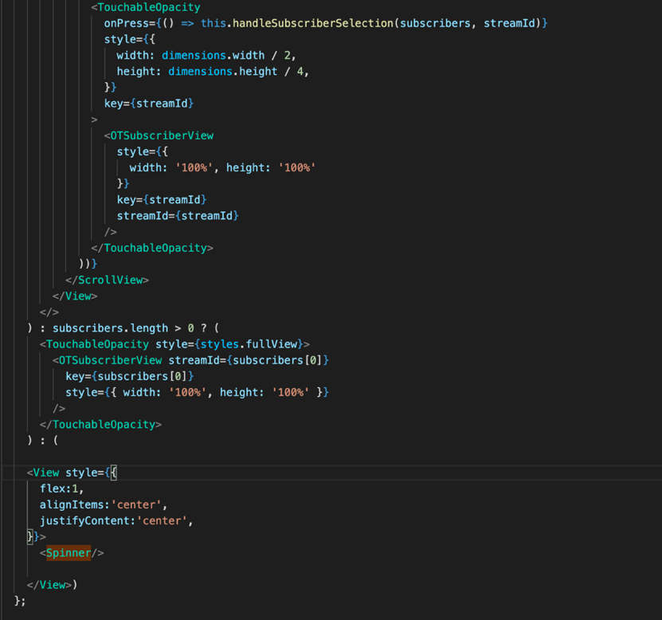

Figure 39

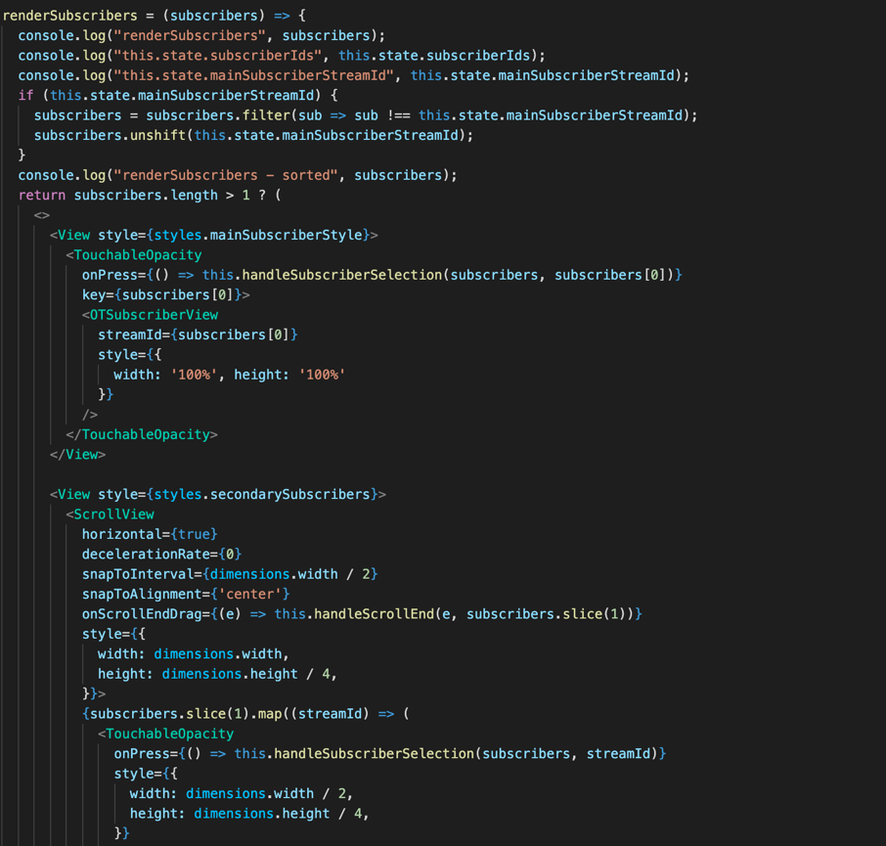

Figure 40

We used the conditional rendering in React to handle the different cases with zero, one or N subscribers. Firstly, if there not subscribers, we fall into last case, and we display a `Spinner animation` component. Secondly, if there is one subscriber, we display the subscriber in a full view mode. Lastly, the most interesting case is when the subscribers are more than one: We have a main subscriber view and a `ScrollView` component ion which we will feed the other subscribers. The first step is to check if we a `mainSubscriberStreamId`. If so, we will sort the array to have the primary subscriber as the first element. The remaining subscribers will be displayed in the `ScrollView` horizontal. The `ScrollView` component is deal for our use case, as we can show a relatively high number of subscribers without the need to change the layout, and we can detect how many subscribers are in the scroll view and how many of them are visible [7].

Group calls on mobile devices could be very challenging, both from the hardware and networking point of view. To deliver a good result to the end-user, an App should implement a list of best practices to handle different use case and layout. In this case, we have a main subscriber view which needs to have the best resolution possible, and the Scroll View component with the remaining subscribers in smaller thumbnails that could be optimized by lowering the received resolution. OpenTok SDKs give the developer the opportunity to set the preferred resolution and frame rate for each of the subscriber [7] [8].

We implement the `handleSubscriberSelection` method to handle the mainSubscriber View and the preferred resolution. The function is on the `TouchableOpacity` component parent of each of the subscribers [7].

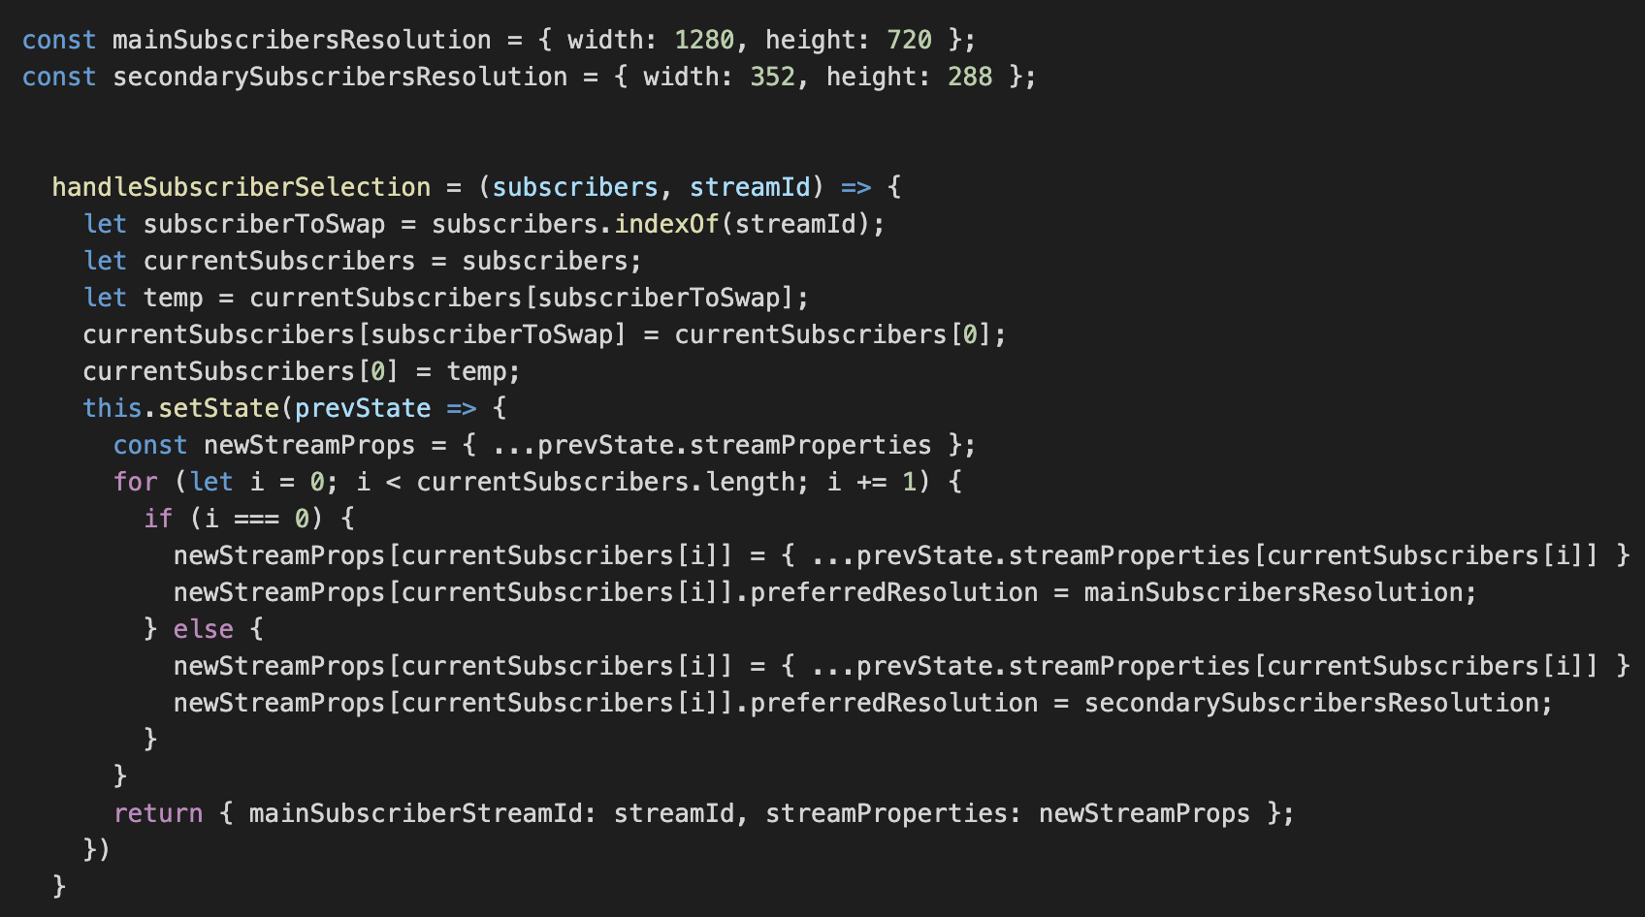

Figure 41

Based on the subscriber selected, the function moves the selected subscriber to the head of the subscribers’ array. As mentioned before, the first element on the subscriber array will be displayed in the main View. After that, we need to update the `streamProperties` of the `OTSubscriber` component to set the different preferred resolution. We set the maximum resolution (`width: 1280, height:720`) for the primary subscriber and a lower resolution for the other (` {width: 352, height: 288} `). If we also want to change the preferred frame rate, based on the layout or use case, we would only need to add the `preferredFrameRate` property on the `streamProperties` object.

Finally, we want to optimize the `ScrollView` component. The ScrollView component could have a high number of subscribers, but can only show two simultaneously. As an example, if we have five subscribers, one will be on the main subscriber view; the remaining four will be on the ScrollView. Only two of them are visible in the View, and the remaining ones will be visible only if we scroll horizontally.

The ScrollView component has an event listener called onScrollEndDrag, which is called when the user stops, dragging the scroll view and it either stops or begins to glide. We can use this event to understand which subscribers are visible and mute the video of the remaining ones. Muting the video of the non-visible stream will improve the performance of the App, and save CPU consumption and network bandwidth [7].

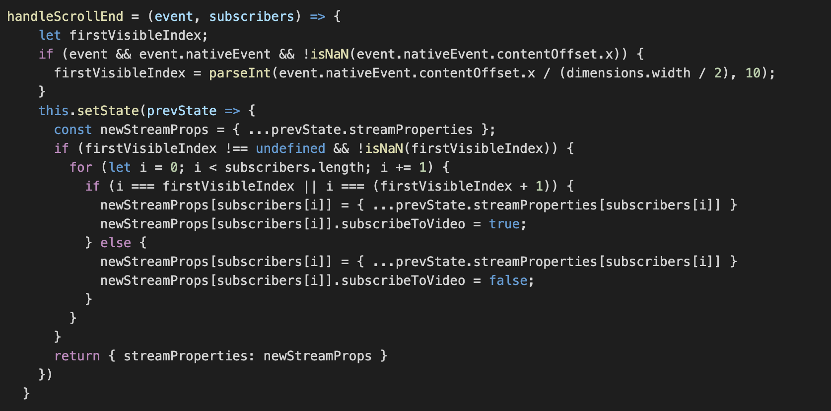

Figure 42

On the `onScrollEndDrag` event, we have the information about the contentOffset coordinates, which is the point at which the origin of the content view is offset from the origin of the scroll view. We will use this value to understand which streams are currently visible, diving the content offset by half of the width of the screen (`event.nativeEvent.contentOffset.x / (dimensions.width / 2)`). The result will be the first visible subscriber.

At this point, we know that the visible streams are the stream in position `firstVisibleIndex` and `firstVisibleIndex + 1`. The last step is to loop the subscribers’ array and mute the video of the non-visible subscribers. Until this session we have implemented the video call in the project, using Vonage APIs [7].

Chapter 4

# CONCLUSION

In this project we achieved our goal of creating a user-friendly application and delivering the promised functionalities. The approaches chosen in the project are far from being the most straightforward solution for creating a mobile app; however, they provide a solid and scalable infrastructure and a structured development process needed for large scale complex applications.

React Native Firebase provided many useful services to make this project possible, and helped tremendously with the development process buy encapsulating much of the server configuration and allowing us to fucus on development of the application without incurring any costs. Since many of the used services were released not too long ago, they have not been widely adopted by the community, so there is relatively fewer articles and sources of information that can be found for them apart from the official documentation. Due to this, some of these tools - especially the less explored sections of them - have a steep learning curve, and it might take a while to get familiar with their definitions and methods. Because of the full-stack nature of this project, many core concepts in different fields of Computer Science had to be thoroughly explored to be able to have a clear vision of each used component’s behaviour, resulting in valuable personal learnings on mobile development.

# **Reference**

|  |  |
| --- | --- |
| [1] | M. B. Doost, "Use of Cloud Technologies in a Modern Scalable Web Application," ELTE, 13 12 2019. [Online]. Available: https://edit.elte.hu/xmlui/handle/10831/46656. |
| [2] | Efilecabinetv, "Efilecabinetv," 07 12 2015. [Online]. Available: https://www.efilecabinet.com/the-benefits-of-closed-source-platforms-for-enterprise/#:~:text=Some%20of%20the%20benefits%20of,friendliness%2C%20support%2C%20and%20security.. |
| [3] | R. Native, "Introduction," 28 12 2020. [Online]. Available: https://reactnative.dev/docs/getting-started. |
| [4] | Mindinventory, "The Advantages and Disadvantages of Using React Native as Cross-Platform App Development," 07 08 2019. [Online]. Available: https://www.mindinventory.com/blog/pros-cons-using-react-native/. |
| [5] | Tristatetechnology, "Why Firebase is the Best Mobile Backend as a Service?," 31 08 2016. [Online]. Available: https://www.tristatetechnology.com/blog/firebase-backend-mobile-app/. |
| [6] | WebRTC, "Real-time communication for the web," 28 12 2020. [Online]. Available: https://webrtc.org/. |
| [7] | Vonage, "Build a Video Conference App With React-Native and Vonage Video API," 12 10 2020. [Online]. Available: https://learn.vonage.com/blog/2020/10/12/build-a-video-conference-app-with-react-native-and-vonage-video-api. |
| [8] | Open-Tok, "opentok-react-native," 28 12 2020. [Online]. Available: https://github.com/opentok/opentok-react-native. |